ADDRESS VALIDATION ISSUES

# **Issue:**

Application: ASOC  
Problem: ADDRESS DISCREPANCY  
RPT_SVC_LINE: VPN  
RPT_SUB_SVC_LINE: BVOIP EaFlex/AVPN  
KEY_ITEM_AFFECTED: 1  
ORG_GROUP_DDL: VPN VB  
ADDRESS: 3130 Seminole Rd, Ft. Pierce 34591  
CORRECT_LSO: 001  
DETAILED_DESCRIPTION: Customer address is correct but not validating in ASOC  
**Sample Ticket:**

**Ticket #: 000000253989162**

**Resolution Steps: (Basic process to add address in ASOC)**

1. **How to check the given address is present in the DB or not -**

**LSO steps -**

1. Go to the link <http://asoc.aldc.att.com:8080/asoc/home.xml>?
2. Login with credentials. Click on Look up LSO.

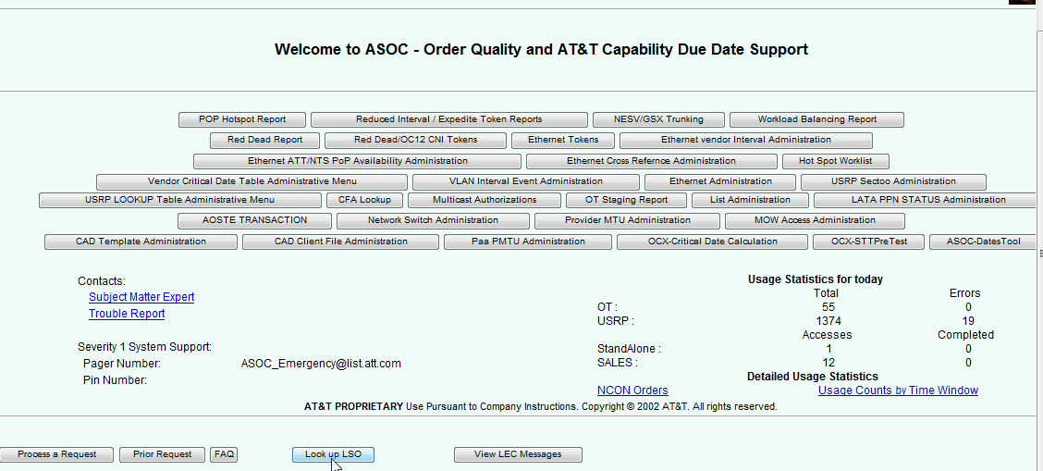

1. User Request –

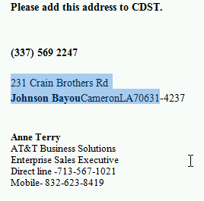

1. Fill all the required information and click on search button

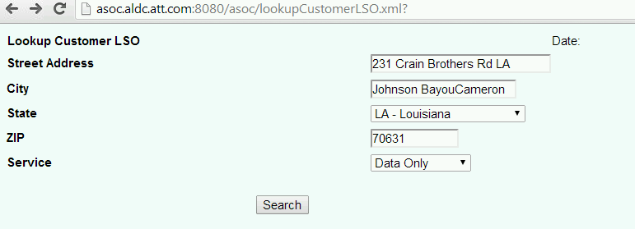

1. If address is present in the DB it will show you the following screen.

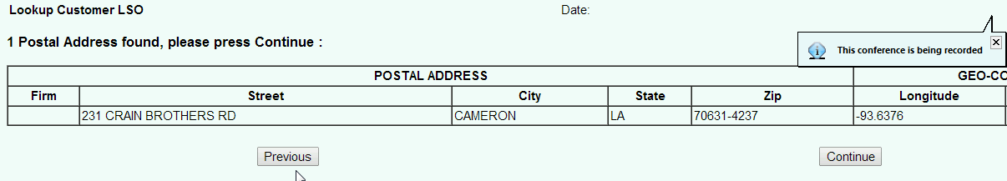

1. If address is not present in the DB, we will get the following error msg. on the screen.

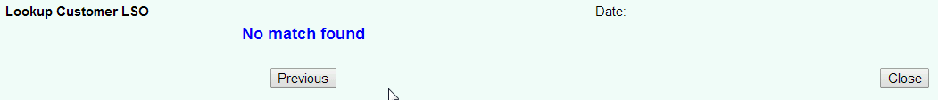

In that case team will find out the latitude and longitude information by performing the

following steps.

1. **Address addition steps**
2. Get latitude ,longitude from google maps
3. Go to AVS or AVW URL: <http://asoc.aldc.att.com:8080/avs/av_home.xml>
4. Login with credentials

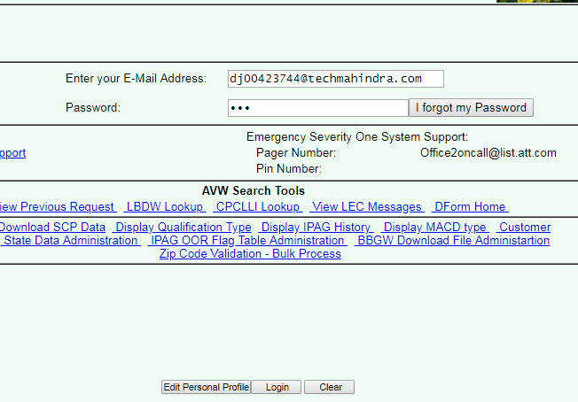

1. Click Admin Menu button on the bottom left

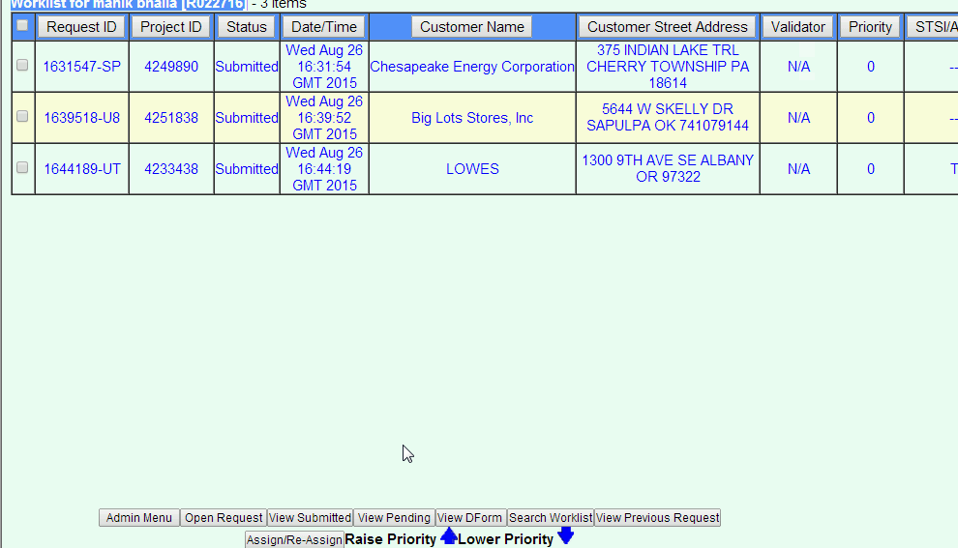

1. Click Admin New Construction Table link

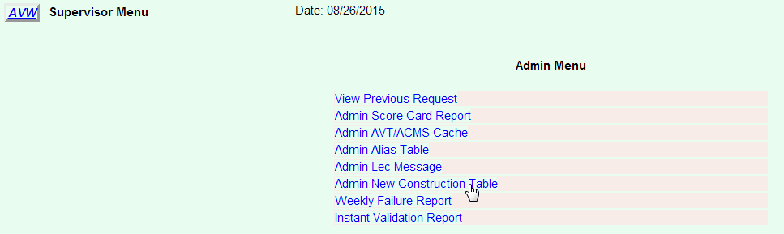

1. Click Add to add a new address or Change after searching and selecting an address

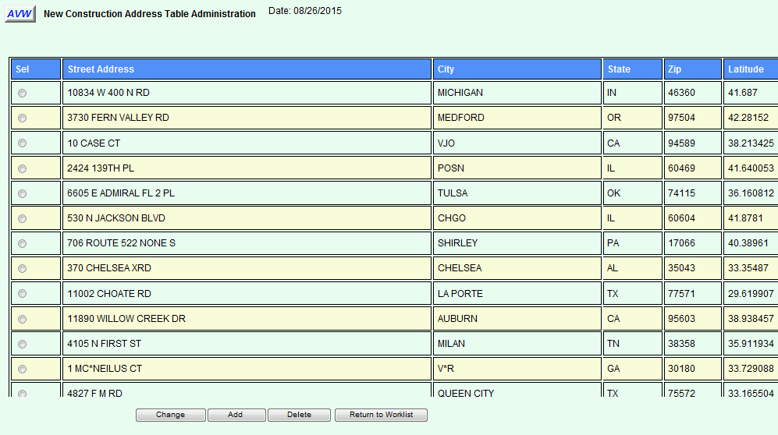

1. There are many fields. Fill all those relevant fields

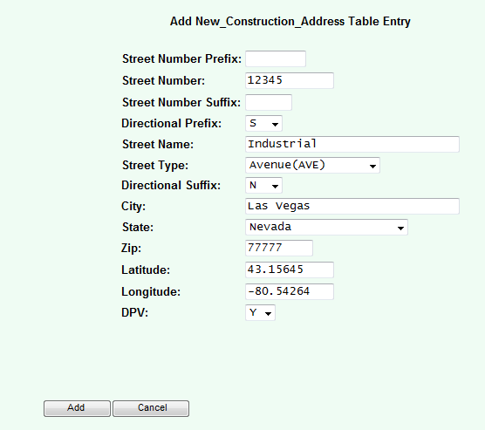

***Note****: 1. If the address does not have a street value such as a Highway address, set the Street Type to None. Click add, and verify through the ASOC Lookup LSO. Sometimes you may have to check the logs to match the parsing that ASOC may be doing in the code forcing you to add the street type to the street name and setting Street Type to None.*

1. *Consider above format as a std. format for address addition*

**Address validation failure cases:**

Case 1: If address validation failed in ASAP

1. Check if address is there in ASOC
2. If address is not there in ASOC, check if address is valid
   1. If valid add that address to ASOC(use usps.com or google maps to check)
   2. If not valid ask user to provide valid address or a document with that address
3. If address is there in ASOC, Check logs on ASOC servers Stated below:
   1. blpv0427.bhdc.att.com
   2. blpv0428.bhdc.att.com
   3. blpv0429.bhdc.att.com
4. Log steps
   1. Go to /lps/logs
   2. Grep ‘street name’ *logAdoptSkinny*date(file name : o4.logAdoptSkinny.W1.20181120)
   3. Check for the error “No match found in Mapinfo” or “No ratecenter Found”
   4. And add address if valid

Case 2: If address fails in Sales Express for Product type VPN VB

1. Check if address is there in ASOC
2. Check logs in /avs/logs (grep ‘street name’ *lec*date)
3. Check if address is validating in LEC

streetNumberSuffix=

streetDirectionalPrefix=W

streetName=TENNESSEE

streetType=ST

streetDirectionalSuffix=

ld1=BLDG

lv1=MAIN

ld2=FLR

lv2=1

ld3=RM

lv3=TELCO

city=TALLAHASSEE

state=FL

zip=32304

]

]}

]

**2018/12/18 00:03:50 Rqst: LECAdval 0003389-3E73 : Result: Validated**

1. If valid in LEC response, check logs in /lps/logs (grep ‘street name’ *logAdoptSkinny*date)
2. Check for any ratecenter error or no response from ASOC
3. Add address as per LEC response
4. if Invalid, check with LEC team for correct address format and add address provided by LEC

Case 3: If address validation fails in GIOM

1. Check address logs provided by GIOM
2. Pick request ID from GIOM and check logs in ASOC server
   1. Go to /lps/logs
   2. Grep ‘request id’ *date*
3. Check address in the input and add if valid
4. If not valid ,ask user to provide valid address or provide the address which is there in ASOC

Case 4: If address validation fails in OCX

1. Check logs provided by OCX
2. Check logs in ASOC using conv id from ocx logs
   1. Go to /lps/logs
   2. Grep ‘conv id’ *date*
3. Check address in the input and add if valid
4. If not valid ,ask user to provide valid address or provide the address which is there in ASOC

**Bvoip Service availability:**

**GIOM sends 2 requests to ASOC, one is TN and other is ADDRESS.**

**For both the requests please check the below tags, all should be Y.**

voIPAvailability=Y,

voipE911Availability=Y,

voipLocalAvailability=Y,

voipCentrexAvailability=Y,

**In addition for address request, serviceAddressIntrado911Indicator should be Y. INTRADO sends this data, It will be Y if response is Enhanced and N if Basic from Intrado.**

2019/11/07 11:53:51 Rqst: SvcAvailImpl 1153445-C771 Parsed addrInfoess = 201 LAUREL RD VOORHEES NJ 08043

2019/11/07 11:53:51 Rqst: SvcAvailImpl 1153445-C771 requestXML = <VUI ver="1.0" xmlns="http://www.intrado.com/namespaces/vui" xmlns:xsi="http://www.w3.org/2001/XMLSchema-instance" xsi:schemaLocation="http://www.intrado.com/namespaces/vui VUI.xsd" ><HDR><Acct>VUI-100178</Acct><ClientVersion>1.0</ClientVersion><REC>1</REC></HDR><Payload><InfoCheckLevelOfServiceRequest ver="1.0" ><HNO>201</HNO><HNS></HNS><PRD></PRD><STN>LAUREL RD</STN><POD></POD><MCN>VOORHEES</MCN><STA>NJ</STA><ZIP>08043</ZIP></InfoCheckLevelOfServiceRequest></Payload><TRL><REC>1</

REC></TRL></VUI>

2019/11/07 11:53:51 Rqst: SvcAvailImpl 1153445-C771 INTRADO_TIMEOUT = 30

2019/11/07 11:53:52 Rqst: SvcAvailImpl 1153445-C771 Completed the process from INTRADO :

2019/11/07 11:53:52 Rqst: SvcAvailImpl 1153445-C771 finals= <VUI xmlns="http://www.intrado.com/namespaces/vui"><HDR><REC>1</REC></HDR><Payload><InfoCheckLevelOfServiceResponse><RC1 message="SUCCESS">0</RC1><QueryID>197919032</QueryID><LevelOfService>Enhanced</LevelOfService></InfoCheckLevelOfServiceResponse></Payload><TRL><REC>1</REC></TRL></VUI>

2019/11/07 11:53:52 Rqst: SvcAvailImpl 1153445-C771 ASOC_INTRADO_intf:parseXML: Finally block closing the string reader :

2019/11/07 11:53:52 Rqst: SvcAvailImpl 1153445-C771 No of Child Nodes of VUI = 3

2019/11/07 11:53:52 Rqst: SvcAvailImpl 1153445-C771 No of Child Nodes of PAYLOAD = 1

2019/11/07 11:53:52 Rqst: SvcAvailImpl 1153445-C771 No of Child Nodes of InfoCheckLevelOfServiceResponse = 3

2019/11/07 11:53:52 Rqst: SvcAvailImpl 1153445-C771 Level of Service Returned from INTRADO = Enhanced

2019/11/07 11:53:52 Rqst: SvcAvailImpl 1153445-C771 INTRADO Response -> Enhanced

**WIRELESS TN Issue:**

**If TN is wireless(Category 98)**

* + 1. Check the TN in same rate center via GUI, and pick up ocn,aocn and switch.
    2. Update that for the TN with category 98 in lps_lerg13 table.

**Notes:**

1. ASOC Servers
   1. blpv0427.bhdc.att.com
   2. blpv0428.bhdc.att.com
   3. blpv0429.bhdc.att.com
   4. blpv0430.bhdc.att.com(DB)
2. Use google maps or usps.com to validate address